**Abstract:**

A diode is one of the simplest electronic devices. It is a unidirectional device. A diode does not behave linearly with respect to applied voltage and has an exponential I-V relationship. There are two operating regions for the diode, reverse biased region, and forward biased region. The diode is simply a semiconductor pn junction. In addition to being applied as a diode, the pn junction is the basic element of bipolar-junction transistors (BJTs) and field-effect transistors (FETs).

**Introduction:**

The objectives of the Experiment 1 of the Electronic Devices Lab are,

1. To become familiar with semiconductor diode.
2. To determine the characteristic curve of a semiconductor diode.

**Theoretical Background:**

**Diode Structure**

The semiconductor diode is created by simply joining an n-type and a p-type material together [1]. It is a pn junction as shown in Figure 1. As indicated, the pn junction consists of p-type semiconductor material in contact with n-type semiconductor material. A variety of semiconductor materials can be used to form pn junctions like silicon, germanium, gallium arsenide etc. However, we will concentrate on silicon, as this is the most widely used material in microelectronics. In actual practice, both the p and n regions are part of the same silicon crystal. The pn junction is formed by creating regions of different doping (p and n regions) within a single piece of silicon. The material is doped by bringing in additional atoms (impurities). The impurities can be either donors or acceptors atoms. The words acceptor and donor can be associated with donating and accepting electrons.

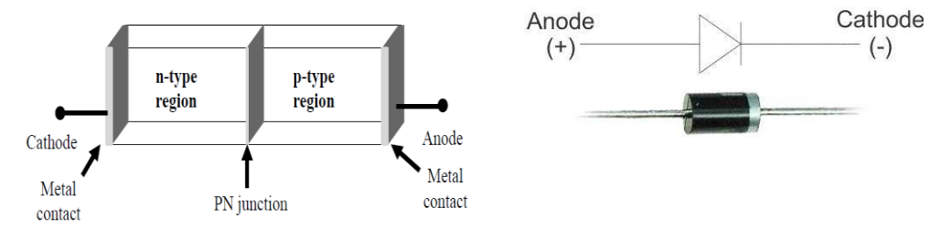

**\**

**Figure 1: pn junction diode structure**

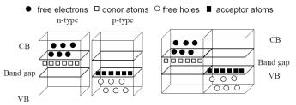

**(a)** **(b)**

**Figure 2: a) energy band diagram of n-type and p-type b) pn junction**

**PN Junction**

To understand how a pn junction is formed we will start by imagining two separate pieces of semiconductor, one n-type and the other p-type as shown in Figure 2(a). Now we bring the two pieces together to make one piece of semiconductor. This results in the formation of a pn junction (Figure 2(b)).

**Forward/Reverse Bias Characteristics**

If negative voltage is applied to p-type material and positive voltage to the n-type material, the diode is in reverse bias. In response, free holes and electrons are pulled towards the end of the crystal and away from the junction. The result is that all available carriers are attracted away from the junction, and the depletion region is extended. There is no current flow through under such conditions.

In forward biased p-n junction diode, the positive terminal of the battery is connected to the p-type semiconductor material and the negative terminal of the battery is connected to the n-type semiconductor material. This has the effect of shrinking the depletion region. Now, electrons in the p-type end are attracted to the positive applied voltage, while holes in the n-type end are attracted to the negative applied voltage.

**Diode Characteristics**

In forward bias condition, a cut-in voltage(also known as knee voltage) has to overcome for the diode to start conduction. In silicon, this voltage is about 0.7 volts. In reverse-bias condition, the current is limited to IS (reverse saturation current). For higher value of reverse voltages, the junction breaks down. Figure 3 shows the diode I-V characteristics.

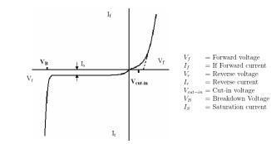

**Figure 3: Diode IV Characteristics**

**Apparatus:**

|  |  |  |
| --- | --- | --- |
| **No.** | **Apparatus** | **Quantity** |
| 1 | Diode | 1 |
| 2 | 10 k Resistance | 1 |
| 3 | Project Board | 1 |
| 4 | DC Power Supply | 1 |
| 5 | Multimeter | 1 |

**Circuit Diagram:**

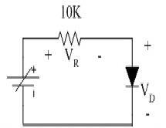

**Figure 4: Circuit diagram for determining diode characteristic in forward bias condition**